**Abstract**

The Learning and Development (L&D) team in large organizations is pivotal in enhancing employee skills, maintaining training compliance, and nurturing a culture of continuous learning. However, managing various training programs, monitoring employee progress, and ensuring content relevance across different roles presents significant challenges. These teams face difficulties in coordinating training schedules, tailoring learning paths, and collecting feedback to refine future programs. Moreover, the rise of remote and hybrid work models has rendered traditional in-person training less viable, necessitating a transition to digital solutions.

**Business Requirements Document (BRD)**

**1. Project Overview**

* **Project Name: L&D Management Application**
* **Project Description:** The L&D Management Application is designed to streamline the process of training and development within an organization. It enables ACCOUNTS TEAM to request training programs, allows the L&D team (Admin) to create and manage these programs, and provides employees with access to training courses, assign mentor, feedback mechanisms, and progress tracking. The goal is to enhance employee skills, ensure compliance with training requirements, and gather insights**.**

**2. Objectives**

* To provide a centralized platform for managing training programs.
* To enable ACCOUNTS TEAM to request training based on organizational needs.
* To allow the L&D team to create, manage, and assign courses to employees with mentor.
* To track employee progress and gather feedback for continuous improvement.

**3. Scope**

* **In-Scope:**
  + ACCOUNTS TEAM can submit training requests.
  + Admin can create courses based on requests.
  + Employees can enroll in and complete courses.
  + Feedback collection after course completion.
  + Progress tracking for employees.
* **Out-of-Scope:**
  + External training integration (e.g., third-party platforms).
  + Multi-language support**.**

**4. Stakeholders**

* **Primary Stakeholders:**
  + Accounts Team
  + L&D (Admin) Team
  + Employees
* **Secondary Stakeholders:**
  + IT Department
  + Compliance Team

**5. Business Requirements**

* BR1: Accounts Team should be able to submit training requests via a form.
* BR2: Admin should be able to view and respond to Accounts Team requests by creating courses.
* BR3: Admin should be able to assign courses with mentor to employees and provide credentials.
* BR4: Employees should be able to log in, view assigned courses, and start learning.
* BR5: The system should collect feedback from employees after course completion.
* BR6: The system should allow the admin to track employee progress and modify courses based on feedback.

**6. Success Criteria**

* Successful creation and assignment of courses.
* High engagement and completion rates from employees.
* Positive feedback and continuous improvement of course content**.**

**7. Assumptions**

* All users will have access to the internet.
* Users will be familiar with basic web navigation.
* Employees will complete courses within the given timeframe.

**8. Constraints**

* The application must comply with organizational security policies.
* Limited budget for initial development and deployment.

**9. Risks**

* Resistance to change from employees.
* Potential delays in course content creation.

**Functional Requirements Document (FRD)**

**1. Introduction**

This document details the functional requirements of the L&D Management Application, focusing on the features that will be implemented to meet business objectives.

**2. Functional Requirements**

* **FR1: User Roles and Authentication**
  + The system must support Team roles: Accounts Team, L&D Team (Admin), and Employee.
  + Each user should have secure login credentials and role-based access.
* **FR2: Account Team Request Submission**
  + Accounts Team should be able to fill out a form to request a training course.
  + Fields include course name, description, concepts, duration, and position required.
  + The status of the request should be set to "PENDING" by default.
* **FR3: Admin Course Management**
  + Admin should be able to view Account Team requests and create a corresponding course.
  + Admin should input course details such as course name, description, outcomes, and course link.
  + Upon course creation, the status of the request should be updated to "COMPLETED."
* **FR4: Employee Course Assignment**
  + Admin should assign courses to employees by adding their email and generating a random password.
  + The system should automatically send an email to the employee with login credentials.
* **FR5: Employee Learning Interface**
  + Employees should log in and view assigned courses.
  + The course content should be accessible via a provided link.
  + The system should track the employee’s progress (e.g., percentage completed).
* **FR6: Feedback Collection**
  + Upon course completion, employees should fill out a feedback form with suggestions, comments, and a rating.
  + The feedback should be stored in the system and linked to the course.
* **FR7: Admin Feedback Review**
  + Admin should be able to review feedback for each course.
  + Admin should be able to modify course content based on feedback.

**3. Use Cases:**

* Use Case 1: Accounts Team Submits Training Request
* Use Case 2: Admin Creates and Assigns Course
* Use Case 3: Employee enrolls and Completes Course
* Use Case 4: Admin Reviews Feedback

**4. User Interfaces**

* Login Page
* Accounts Team Dashboard
* Training Request Form
* Admin Dashboard
* Course Creation Form
* Employee Dashboard
* Feedback Form

**5. Data Flow**

* Accounts Team submits request → Admin creates course → Employee enrolls and completes → Feedback is collected and reviewed.

**Non-Functional Requirements Document (NFRD)**

**1. Performance Requirements**

* NFR1: The system should support up to 500 concurrent users without performance degradation.
* NFR2: Response time for form submissions should be less than 2 seconds.

**2. Security Requirements**

* NFR3: User passwords should be stored securely using encryption.
* NFR4: Role-based access control should be implemented to prevent unauthorized access.
* NFR5: All communications should be secured using HTTPS**.**

**3. Usability Requirements**

* NFR6: The user interface should be intuitive and easy to navigate, with a maximum of 3 clicks to access major functionalities.
* NFR7: The application should be accessible on both desktop and mobile devices.

**4. Reliability Requirements**

* NFR8: The system should have an uptime of 99.9% during business hours.
* NFR9: The system should handle unexpected shutdowns by saving user progress and states.

**5. Scalability Requirements**

* NFR10: The system should be scalable to accommodate additional users, courses, and content without significant refactoring.

**6. Compliance Requirements**

* NFR11: The system should comply with data protection regulations, such as GDPR, for handling user data.

**7. Backup and Recovery**

* NFR12: Daily backups should be performed, and the system should be able to recover data within 1 hour in case of a failure.

**8. Maintainability**

* NFR13: The codebase should be modular and documented to facilitate easy updates and bug fixes.

**Architecture Diagram**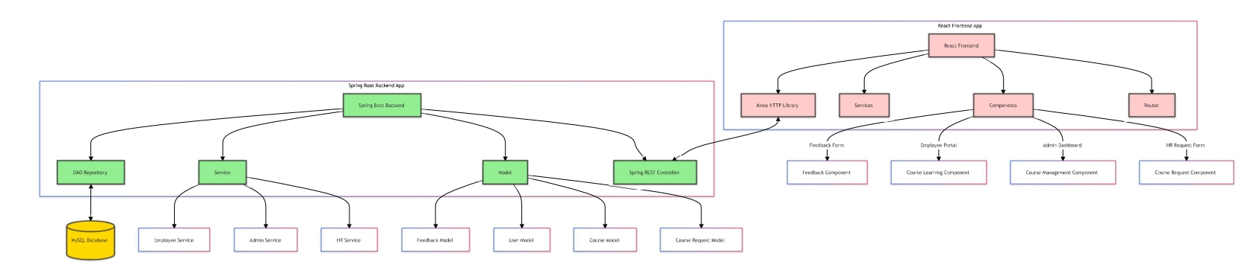

**Database Schema**

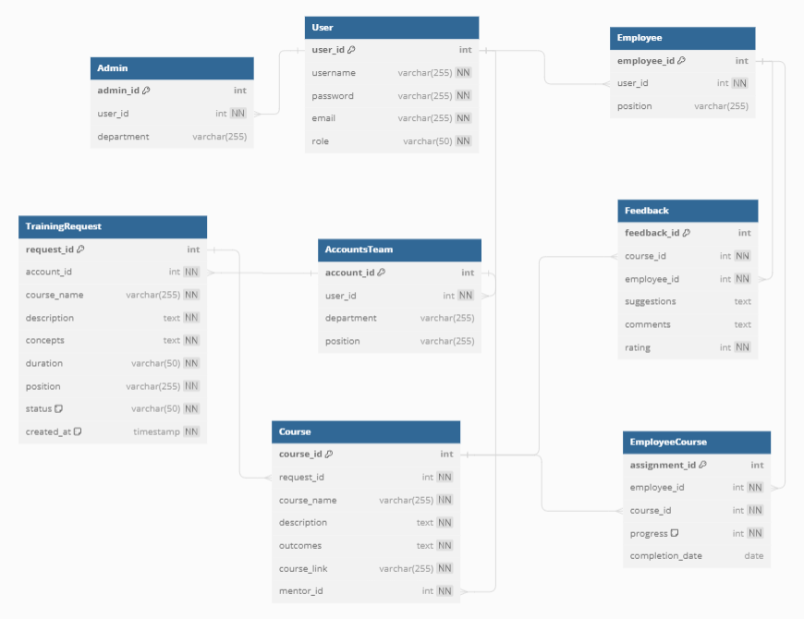

**Wireframe:**

**Accounts Team** [**https://www.figma.com/proto/Z3KHcv9jJBHyMW2HzLQaoD/Accounts Team?node-id=5-68&t=lW51rqIgtJMYo7wL-1**](https://www.figma.com/proto/Z3KHcv9jJBHyMW2HzLQaoD/Hr?node-id=5-68&t=lW51rqIgtJMYo7wL-1)

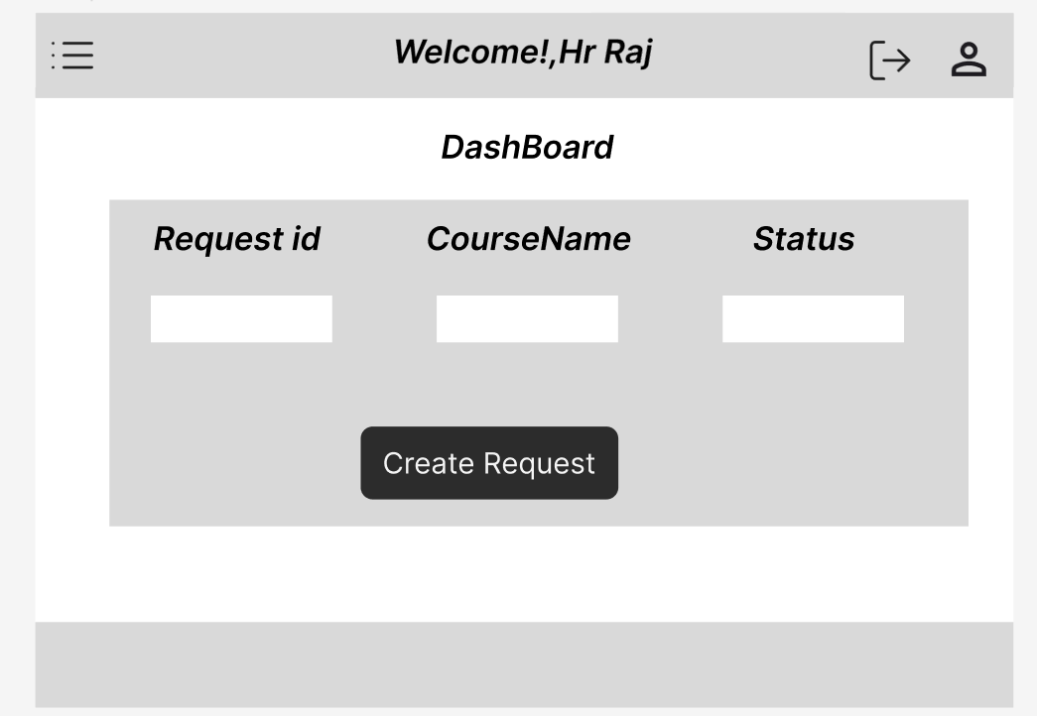

**L&D Admin page:**

[**https://www.figma.com/design/IUIa4NByoEhfLunVBc7OnF/Admin-Console?node-id=43-162&t=PAAShoYN1itBl60v-0**](https://www.figma.com/design/IUIa4NByoEhfLunVBc7OnF/Admin-Console?node-id=43-162&t=PAAShoYN1itBl60v-0)

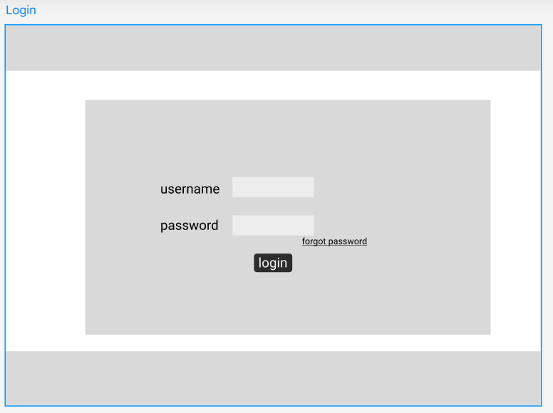

**Employee** [**https://www.figma.com/proto/Z3KHcv9jJBHyMW2HzLQaoD/Accounts Team?node-id=5-36&t=lW51rqIgtJMYo7wL-1**](https://www.figma.com/proto/Z3KHcv9jJBHyMW2HzLQaoD/Hr?node-id=5-36&t=lW51rqIgtJMYo7wL-1)



